Geislingen an der Steige, 14th October 2020

WMF Partners all around the world know the secrets behind
a good cup of coffee
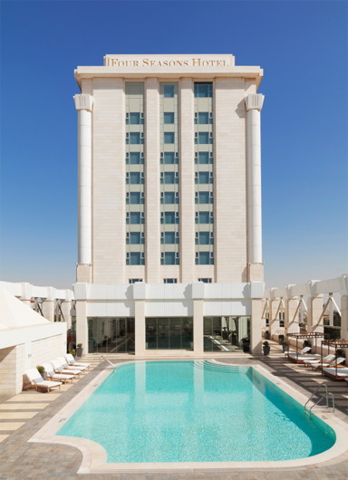
AL – AHLIA Hotel Supplies Co. is one of the largest suppliers and contractors of equipment to the food industries in Jordan. To meet the increasing rise in local coffee consumption, the company decided in 2010 to include the products of WMF Professional Coffee Machines in its solution portfolio. The convincing brand mission of the market leader from Germany was the decisive factor in choosing the machine supplier from Geislingen/Steige: seamless, premium experience.
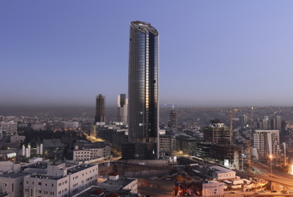
With this mindset, AL – AHLIA Hotel Supplies Co. now provides customers in the Jordan market with a wide range of high-quality coffee solutions for operated and self-service concepts. “Our customers choose WMF products because they boast outstanding technical performance and are very reliable. They are impressed by the quality approach and strong brand. We are very pleased with this collaboration and are working to attract more customers and orders in the future,” says Khaled Omer, General Manager of AL – AHLIA.

The customers of the Jordan supplier include renowned clients from the entire HoReCa sector (Hotels, Restaurants, Catering) such as several Mövenpick Group companies, the four Seasons Hotel Amman, the Amman Rotana Hotel and also companies like Coffee City Shop and the Expedia Group. The areas of application are as varied as the flexibility of the fully automatic machines promises. The fully automatic machines WMF 1500 S or WMF 5000 S, for example, perform their duties in SPA areas as well as in the lobby or at the bar. The flagship WMF 9000 S+, on the other hand, can often be found in catering on the floor and at the hotel buffet, but also in staff catering.

Furthermore the WMF machines offer special economic advantages thanks to the integrated telemetry solution WMF CoffeeConnect. The continuous, bundled monitoring of the machine processes provides WMF customers with a wealth of user-friendly evaluation and control options to increase the efficiency and profitability of the coffee business. Among the highlights were in-depth analytical reports on sales and turnover figures as well as the possibilities around predictive maintenance and sales forecasting.

Image request
You can find images on our media portal http://press-n-relations.amid-pr.com (search term “WMF-ALAHLIA”).

Further information:  WMF Group GmbH  Eva Gold  Senior Manager Global Brand & Communications  GBU Professional Coffee Machines  Eberhardstraße 35 – 73312 Geislingen, Germany  Tel.: +49 73 31 25 8589  EGold@wmf.com - www.wmf.com | Press and public relations:  WMF Pressebüro  c/o Press’n’Relations GmbH  Monika Nyendick  Magirusstraße 33 – 89077 Ulm, Germany  Tel.: +49 731 96287-30  wmf@press-n-relations.de  www.press-n-relations.de

About the WMF Group
For over 160 years, WMF has been dedicated to achieving the perfect balance of design, functionality and quality. The company, based in southern Germany, is a global market leader in the Professional Coffee Machines (PCM) sector. With the aim of being the first choice worldwide for professional coffee solutions, the “made in Germany” quality seal combines premium products and innovative strength with peak performance and reliability.

At the core of the WMF PCM solutions portfolio is a clear message: Designed to Perform. The business unit from Geislingen an der Steige has just the right concept for every business model in the coffee sector – from high-performance fully automatic machines for coffee specialities and filter machines right through to fully automatic portafilters and innovative digitalisation concepts. Moreover, national and international customers alike benefit from high-quality consulting and service, based on the largest in-house service organisation for professional coffee machines in Europe. Regular training courses in the WMF training centres ensure that this expertise is continuously passed on to the entire global WMF service network.

At the end of 2016, WMF Group became part of the French Groupe SEB consortium. In this context, all B2B brands of the Group were recently brought together under the umbrella “SEB PROFESSIONAL”. In addition to WMF PCM, the umbrella brand also includes Schaerer and Wilbur Curtis coffee machines as well as the business division Professional Hotel Equipment with the brands WMF Professional and HEPP.

