Großbottwar, 1 April 2025

iba 2025 - 18 to 22 May – Trade Fair Düsseldorf (Hall 14/Stand D31)

WIESHEU Group: Concentrated baking expertise at iba
Dibas PICCOLO C combines the know-how of WACHTEL and WIESHEU

The group of companies comprising of WIESHEU, WACHTEL ABT, Atollspeed, Winnovation and CoBa AfterSales will be presenting their combined expertise in hot-air, deck, rack and hybrid technology at the iba in Düsseldorf. The joint trade fair appearance in Hall 14, Stand D31 will focus on the comprehensive product and service portfolio from a single source. With its premium rack and deck ovens, WACHTEL addresses the bakery trade in the bakehouse and production. With its in-store baking ovens, WIESHEU focuses on in-store baking at the POS, including branch operations of bakeries and bakery shops as well as food retailers and the convenience sector. The expertise and know-how of both companies is particularly reflected in the jointly developed Dibas blue2 PICCOLO C combination - one of the highlights on the iba stand. The baking station combines the best of two worlds for maximum flexibility and efficiency: the modern hot-air baking technology of the Dibas blue2 from WIESHEU and the PICCOLO Pro Plus deck oven from WACHTEL. The high-speed appliances from the Atollspeed H series, also on show, combines hot air, impingement heat and microwave for the preparation of hot snacks, making it the perfect addition to bakeries, petrol stations, c-stores and restaurants.

Dibas blue2 PICCOLO C - The best of WACHTEL and WIESHEU in a single baking unit
The Dibas blue2 PICCOLO C combines up to four ovens (one Dibas blue2 and up to three PICCOLO Pro Plus), offering customers the opportunity to bake a wide range of top-quality baked goods in the smallest of spaces. One of the equipment highlights is the door of the Dibas blue2, which is unique on the market: it disappears into the side of the housing when opened and is a clear plus in terms of space utilisation and work safety. The optimised steam system impresses with short heat-up times, optimised heat and steam distribution, low energy consumption and perfect, even baking results. The PICCOLO C deck oven scores with its patented MULTI ZONE BAKING technology: four separately controlled heating zones in each baking chamber ensure a homogeneous baking atmosphere and prevent heat build-up in the rear area - even after long periods of standing at high temperatures. The POWER STEAM system produces a richer steam for a shinier, more even result.

ATLAS EVO 3 from WACHTEL: Efficient, service-friendly, flexible
In bakeries and production plants, there is a particular demand for system solutions that sustainably reduce energy costs without compromising on the quality of the baked goods. For more than 100 years, WACHTEL ABT has stood for long-lasting quality ‘Made in Germany’, pioneering technology and energy-efficient and environmentally friendly system solutions for the bakery trade in bakehouses and production plants. With the ATLAS EVO 3, the long-established company from Hilden in North Rhine-Westphalia presents the further development of the established classic ATLAS rack oven, setting new standards in terms of energy efficiency, user-friendliness and service optimisation. This all-rounder not only impresses with its top baking quality and simple operation thanks to the IQ-TOUCH control system. The ENERGY MANAGER, the IQ GREEN LABEL functions, the triple insulating glassand the optimised separation of the chassis from the baking chamber ensure maximum energy efficiency. The ATLAS EVO 3 can be flexibly operated with gas, oil or electricity. Switching between the energy sources is possible at any time and is simple and cost-effective thanks to the identical design of the base body.

Dibas smart: The modular baking system
The Dibas smart from WIESHEU presented in Düsseldorf is also modular, can be flexibly combined and is efficient. The modular product group from the pioneer and market leader in baking at the point of sale consists of the Dibas smart S and the Dibas smart L.The Dibas smart S/L combination offers space for up to 15 trays and thus a total baking area of more than 3.5 square metres. Alternatively, two Dibas smart S ovens can be combined The in-store baking oven also impresses with its optimised energy balance, simple operation and a hygienic baking chamber that is resistant to corrosion and dirt. This ensures a perfect and even baking result. The equipment highlights include proven Dibas features such as the automatic cleaning system, either as a tank system with liquid cleaner or as a cartridge with solid cleaner. The baking ovens within a baking unit, which are independent of each other in terms of baking technology, can be controlled via touchscreen operation. The Dibas smart can also be equipped with a loading system for fast loading and unloading.

Atollspeed, Winnovation and CoBa AfterSales complete the iba presentation
In addition to products from WIESHEU and WACHTEL, the Group will also be showcasing the Atollspeed high-speed appliance in Düsseldorf. The combination of hot air, impingement heat and microwave prepares a variety of snacks to perfection. The experts from Winnovation will also be on site at the iba stand. Bakehouses, bakery outlets and food retailers alike will benefit from the professionals' innovative solutions and automation expertise. The trade fair presentation will be rounded off by the services of CoBa AfterSales GmbH. The Group's own service partner offers a nationwide network and is the central point of contact for maintenance - also as part of individual maintenance contracts - repairs, spare parts and software updates. The range of services also includes the optimisation of customer processes for all ovens.

Image material (source: WIESHEU GmbH):
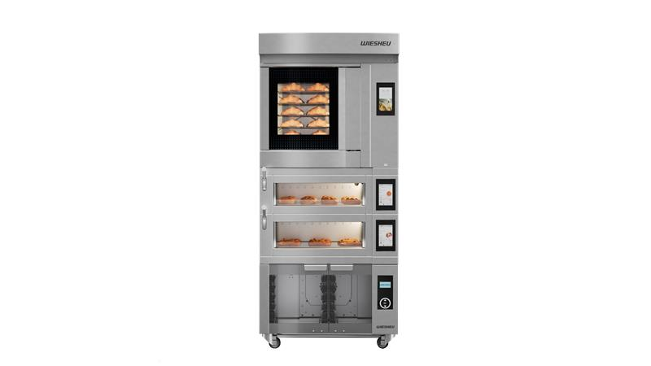
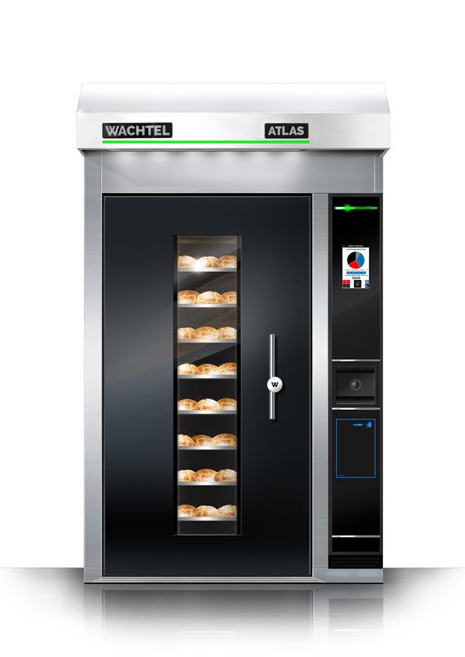

The ATLAS EVO 3 from WACHTEL The Dibas blue2 PICCOLO C combination from WACHTEL and WIESHEU

You can download the images from our media centre
press-n-relations.mediamid.com (search term: „WIH-iba“)

Further information:  WIESHEU GmbH  Julia Rümmele-Hauser  Head of Marketing & Communications  Schleifwiesenstraße 27  71723 Großbottwar  Germany  Phone +49 7148 1629 - 116  julia.ruemmele@wiesheu.de  www.wiesheu.de | Press relations:  Press’n’Relations GmbH  Magirus-Deutz-Straße 14  89077 Ulm  Germany  www.press-n-relations.de  Nataša Forstner  T: +49 731 146 156-77  M: +49 163 579 02 57  nfo@press-n-relations.de  Nina von Imhoff  T: +49 731 14615678  M: +49 163 334 52 45  nvi@press-n-relations.de
About the WIESHEU Group
Since 2023, the companies WIESHEU GmbH, WACHTEL ABT GmbH, Atollspeed Europe GmbH, WINNOVATION GmbH and CoBa AfterSales have been operating as a group of experts in the field of professional baking. With the combined strength of more than 150 years of market and technological expertise, the group of companies stands for the development, sales and service of innovative, professional bakery equipment - from kiosks to bakeries and artisan production all the way to food retailers. With more than 10,000 ovens ‘made in Germany’ every year, the companies are internationally positioned and support bakeries with their range of products and services in offering their customers baked goods of the highest quality.
www.wiesheu.de
www.wachtel.de
www.atollspeed.eu
www.winnovation-gmbh.de
www.coba-aftersales.com

