Schaerer ProCare – easy, reliable, efficient
Rethinking system cleaning of professional coffee machines

Zuchwil, 16. March 2023 – The new Schaerer ProCare cleaning system turns what you know about the system cleaning of professional coffee machines on its head. For up to three months, the patent-pending concept cleans the coffee and milk system fully automatically – without the involvement of service staff. “When developing the Schaerer ProCare, the idea was to fundamentally change the cleaning process by automating it to such an extent that system cleaning is basically no longer an issue for our customers. Hygiene, servicing, handling, transport – the Schaerer ProCare has optimised all of this”, says Laurent Häfliger, Project & Life Cycle Manager at Schaerer and part of the Schaerer ProCare development team of 15 people. What is special about the Schaerer ProCare: The optional accessory available for the Schaerer Coffee Soul models stores highly concentrated alkaline and acidic powder in two bags, each 600 grams in volume. For each cleaning cycle, only the amount needed to obtain an optimally dosed solution is dissolved in water, which is then fed to the coffee machine. The desired time for system cleaning can be programmed individually, and the entire process takes just under 15 minutes. The remaining powder stays at the bottom of the bag and is enough to perform one hundred fully automatic cleaning cycles. The empty bag is easy to replace and recycle thanks to its mono-plastic composition. This means the Schaerer ProCare ensures maximum hygiene and has positive effects on the service life of the coffee machines as well as the beverage quality. It also reduces operating costs thanks to the optimised supply of cleaning agent and less service work.

High customer value with any business model
Most professional coffee machine failures are caused by inadequate or incorrect cleaning, despite efficient cleaning systems. “For example, people forget to add cleaning agent or add too much, thinking “a lot helps a lot”. In the worst case scenario, cleaning is sometimes unfortunately put off to the last possible minute, which is not only questionable in terms of hygiene, but also shortens the service life of the machine. Too much cleaning agent also drives up material costs unnecessarily”, explains Felipe Quintans, Product Manager at Schaerer and also a member of the development team. Direct customer feedback also supports the following: Especially in times of increasing staff shortages and high fluctuation, it is getting harder and harder to make sure that the few employees carefully carry out all work steps under time constraints or that new staff is adequately trained. This is where the Schaerer ProCare comes in and creates the highest level of reliability thanks to a high degree of automation over a period of one hundred days. The regular cleaning also helps to maintain high beverage quality for consumers. For business models in which coffee machines are operated in self-service mode – for example in offices or in public areas such as airports – the Schaerer ProCare has yet another advantage: Since service work can be significantly reduced, staff deployment and travel costs are saved.
Bags with powder instead of tabs and liquid cleaner
What is unique about the Schaerer ProCare cleaning concept compared to other systems is the storage of the cleaning powder in two closed bags. “With the Schaerer ProCare, employees no longer have to spend time filling dosing systems with tabs. When the powder is used up, the empty bag is simply removed and a new one is put in. This makes handling really easy for staff”, explains Häfliger. In addition, the highly concentrated powder mixture in bags saves a lot of space during storage and transport. In liquid form, this would be two 6-litre canisters instead of the two 600-gram bags used in the Schaerer ProCare. In the Schaerer ProCare module, the bags fill with water to supply the two solutions needed for the cleaning process. The alkaline solution is used for the coffee system, and both are used for the milk system, as this is the most efficient way to clean parts that come into contact with milk. The Schaerer ProCare always ensures the optimum dosage. The dosage is continuously checked by a sensor and water is added in a controlled manner to make sure that the optimum concentration is achieved until the end. “Only the so-called last mile, meaning the connecting hose between the machine and the milk container, still has to be manually connected to the Schaerer ProCare. But this is very simple and is done when filling up the milk. Simply take the end piece out of the milk container and insert it into the Schaerer ProCare module. The hose is then rinsed automatically”, explains Quintans. A nice side effect: When filling or cleaning the milk container, the end of the hose is out of the way, so it does not hang down and drip on anything.

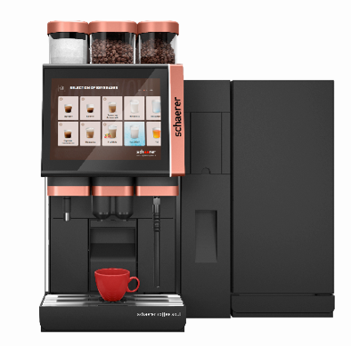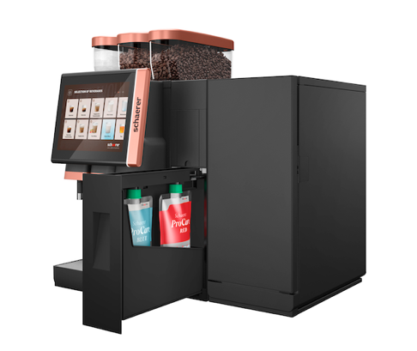

The Schaerer ProCare cleaning system is integrated between the coffee machine and the milk system to save space.

Image availability
You can find downloadable image material in our media portal press-n-relations.amid-pr.com (search term “Schaerer-Pro-Care”). Of course, I would also be happy to send you the files by e-mail. Contact: nfo@press-n-relations.de

Further information:
Schaerer AG
Monika Kammermann, Global Communications Manager
Allmendweg 8, 4528 Zuchwil
Tel.: +41 32 681 64 35
MKammermann@schaerer.com
www.schaerer.com
https://aboutwmf.com/de/news-media/newsroom/schaerer/

Schaerer Press Office
c/o Press'n'Relations GmbH,
Nataša Forstner
Magirusstrasse 33, D-89077 Ulm, Germany
Tel.: +49 731 96 287-17
Fax: +49 731 96 287-97
nfo@press-n-relations.de
www.press-n-relations.de

Schaerer AG
Founded in 1892 and headquartered in Zuchwil, Switzerland, Schaerer AG is one of the world’s leading manufacturers of fully automated professional coffee machines. As a traditional company with many years of history, the Schaerer brand stands for Swiss values combined with an in-depth knowledge of coffee. The company expresses these brand attributes with the company logo “swiss coffee competence” and experiences them equally in its product development and in the Coffee Competence Centre, Schaerer’s own coffee expertise and training centre in Zuchwil. Moreover, Schaerer is characterised by extreme flexibility with the guiding principle “We love it your way” — be it in reference to customer requests, customer-specific products and large orders or the product range which offers the customer a wide range of customised configuration options. Customer-oriented and with extensive coffee knowledge, Schaerer supports customers of any size all over the world in offering their guests the highest level of coffee enjoyment.

Schaerer has been part of WMF since 2006 and of the French consortium Groupe SEB since the end of 2016. All B2B brands of the Group are bundled in the “SEB PROFESSIONAL” consolidated sales organisation. In addition to Schaerer, it includes the WMF and Wilbur Curtis coffee machine brands as well as the Professional Hotel Equipment division with the WMF Professional and HEPP brands.

