Schaerer presents "MilkCheck":
New milk scale optimises ingredient management and service tasks

Zuchwil, 18 October 2024 – Coffee machine manufacturer Schaerer presents the innovative "MilkCheck" milk scale in the area of ingredient management for coffee concepts. The compact scale offers continuous monitoring of milk container fill levels and the cooling chamber temperature. This goes much further than the familiar "low" or "empty" status indicators: The continuous fill level indicator delivers precise, weight-based real-time data on milk supplies allowing operators optimal planning and scheduling of refill processes. This proactive planning with customisable notifications results in more efficient personnel deployment, saving time and costs. Empty milk containers and lost sales due to coffee machine downtimes are also avoided. In addition, "MilkCheck" continuously monitors the temperature of the cooling chamber, contributing to maintaining hygiene standards and ensuring customer safety. The milk scale can be used with any pack type, such as containers, bag-in-boxes or Tetrapaks. It can also be used for cooling units from different manufacturers. Integrated into the various usage scenarios of Schaerer coffee machines, "MilkCheck" will be presented to the public for the first time at the international trade fair FHA - HoReCa 2024 in Singapore (22 - 25 October, Stand 2G2-08) and at Gulfhost in Dubai (7 - 11 November, Stand Z5-B51).
How many coffee machines need to be replenished? Where are they positioned? How many staff members are available to service them? Are the machines to be used for self-service by guests or for operation by the staff? "MilkCheck" allows operators to respond with precision to their individual needs and on-site conditions, avoiding unexpected bottlenecks. To achieve this, you can freely select the fill level at which an advance warning is issued. For example, a message can be generated as soon as the milk supply falls below 0.5 litres. When connected to the Schaerer Coffee Link digital solution, users have further evaluation options by accessing the current actual milk level value as well as low and empty messages. This information can be issued on any end device, supporting proactive and data-based operational management. As well as container fill levels, "MilkCheck" also continuously monitors the temperature in the cooling chamber: If the defined temperature limit is exceeded, speciality coffee dispensing can be automatically blocked, ensuring the quality of the beverages and the safety of consumers.

Compatible with different cooling units
"MilkCheck" is suitable for retrofitting and is compatible with different cooling units, meaning customers can also use it with existing equipment, including from other manufacturers. Due to the dimensions of the milk scale (W x D x H: 156 mm x 290 mm x 16.5 mm), the under-counter cooling unit with 2 x 10-litre containers (EU approval) from the Schaerer range is an ideal option. Anyone wanting to use "MilkCheck" together with the Schaerer Twin Milk System for supplying two different types of milk or vegan plant-based drinks will need two scales. This means the fill level of each container can be monitored separately. Minor adjustments may be required for coolers from other manufacturers. This may include openings for the milk hoses and the cable for the scales, as well as the installation of a CAN node.

A bonus for sustainability
Schaerer's "MilkCheck" offers a solution that not only increases efficiency in daily operations, but also contributes to sustainability. By closely monitoring milk consumption, operators can calculate their needs more accurately and reduce waste. In addition, the free choice of container permits the use of environmentally friendly packaging options. In developing "MilkCheck", Schaerer is responding to the increasing requirements for flexibility, efficiency and sustainability in the out-of-home market and is once again underlining its commitment to innovation, customer benefit and sustainability.

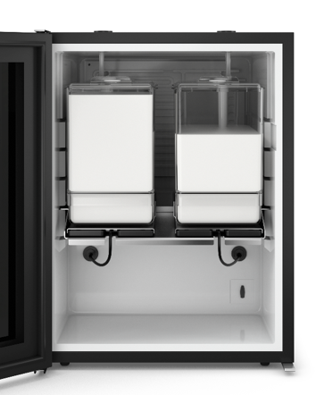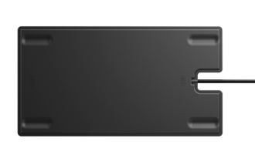

Image availability
You can find downloadable image material in our media portal press-n-relations.amid-pr.com (search term: Schaerer MilkCheck) I would of course be happy to email you the files as well. Contact: nfo@press-n-relations.de

Further information:
Schaerer AG
Sarah Ognibeni
Niedermattstrasse 3b, CH-4528 Zuchwil, Switzerland
Tel.: ++41 32 681 62 00
info@schaerer.com
www.schaerer.com
https://aboutwmf.com/de/news-media/newsroom/schaerer/

Schaerer Press Office
c/o Press'n'Relations GmbH,
Nataša Forstner
Magirus-Deutz-Straße 14, D-89077 Ulm, Germany
Tel.: +49 731 146 156-77
nfo@press-n-relations.de
www.press-n-relations.de

Schaerer AG
Founded in 1892 and headquartered in Zuchwil, Switzerland, Schaerer AG is one of the world’s leading manufacturers of fully automated professional coffee machines. As a traditional brand with many years of history, Schaerer stands for Swiss values combined with an in-depth knowledge of coffee. The brand expresses these attributes with the motto “swiss coffee competence” and experiences them equally in its product development and in the Coffee Competence Centre, Schaerer’s own coffee expertise and training centre in Zuchwil. Moreover, Schaerer is characterised by extreme flexibility with the guiding principle “We love it your way” — be it in reference to customer requests, customer-specific products and large orders or the product range which offers the customer a wide range of customised configuration options. Customer-oriented and with extensive coffee knowledge, Schaerer supports customers of any size all over the world in offering their guests the highest level of coffee enjoyment.

Since 2016, Schaerer has been part of the French Groupe SEB.

