Bonn, 13. April 2023
ORBCOMM at transport logistic (9-12.05.2023, Hall A3, Stand 205)
All transports under control - on both land and sea
Innovations and enhanced solutions for end-to-end cold chain security as well as global tracking and controlling of freight and transport vehicles/assets
The focus of this year's trade fair appearance is entirely on ensuring reliable and economical supply of dry and refrigeration chains on land and sea routes worldwide. As a pioneer in IoT technology, ORBCOMM will be presenting three solutions for transparently tracking and controlling all types of freight in containers, trailers and trucks. The new and easy-to-install cold chain management solution ensures that logisticians can quickly have customisable real-time monitoring options and thus reliable control options for trucks, vans, refrigerated/dry trailers and intermodal containers – regardless of load, location, time and means of transport. Perfectly tailored to the rough requirements of maritime transport routes is ORBCOMM's solution for the continuous monitoring of dry containers being transported across the world's oceans. Real-time information on the location of trailers and containers as well as the condition of the cargo is provided by ORBCOMM's dry trailer tracking and monitoring, which ensures transparency at all times, together with optional global satellite connectivity, cargo camera sensors and tractor ID sensors.
Based on the RT 8 series of devices, ORBCOMM is showing its new cold chain management solution. The RT 8000 solution offers real-time temperature monitoring, comprehensive data acquisition and is compatible with wireless sensors for refrigerated trailers, trucks and vans. It provides temperature-controlled transport companies with a wide range of fuel and temperature management, maintenance and logistics services. In addition, they have additional connectivity and bandwidth thanks to 5G connections, improved EN 12830 compliance, several new interfaces and the latest wireless temperature sensors. This enables them to meet a wide range of traceability, compliance and control requirements.
When are the containers moving? How much progress has the container shipment from Shanghai made? How long has the cargo remained in the port? Answers to these questions are provided by the new telematics solution for seamless monitoring of dry marine containers that pass through complex supply chains around the globe. The new ORBCOMM CT 1000 device digitises global container shipping and provides shipping lines and their customers with constantly updated information and reliable traceability. This enables them to implement decisions on maritime activities based on valid real-time data. The solution, which is used by Hapag Lloyd among others, offers cost-effective and worldwide LTE coverage and supports a wide range of standard wireless sensors via Bluetooth.
A high degree of safety, reliability and long service life when monitoring trailers, containers and chassis is offered by the wide range of solutions for dry trailer tracking and monitoring. It includes not only solar-powered tracking devices with or without integrated load sensor (GT 1200/1210), but also additional cargo camera sensors for monitoring the load (CS 500) and tractor ID sensors for pairing trucks with trailers (IS 400). While the cargo camera sensor automatically or manually takes interior pictures of trailers to optimise loading as well as pictures of the load at various driving events, the tractor ID solution ensures that the correct trailers are connected to the truck. The rugged ST 2100 satellite tracking device provides reliable and cost-effective satellite connectivity for a wide range of industrial equipment in remote locations. Environmentally sealed, it can be installed on both fixed and mobile equipment for a wide range of applications.
Recent developments have shown the tremendous importance of reliably functioning supply chains. This requires that they can also be adapted flexibly and promptly if conditions change. At the ORBCOMM stand (A3/205), the proven telematics and IoT experts will present practical solutions that enable companies to make data-driven decisions to optimise their processes, make them more sustainable and increase profitability.

Illustrations
ORB_RT-8000.jpg, ORB_RT-8110.jpg, ORB_RT-8120.jpg

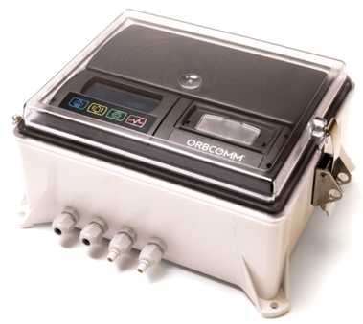

For faster temperature monitoring, improved connectivity with other devices and enhanced compliancy, with the RT 8000 (left) for real-time monitoring, and temperature dataloggers RT 8110 for refrigerated trailers (centre) and RT 8120 for refrigerated trucks and vans (right). (Photos/Graphics: ORBCOMM)

ORB_CT-1000.jpg
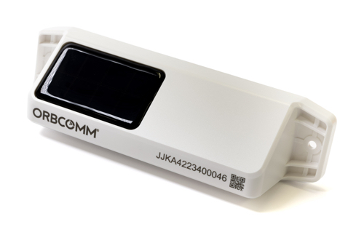

All dry containers around the world under control – with the dry container solution CT 1000 from ORBCOMM (Photos/Graphics: ORBCOMM)

ORB_CS-500.jpg, ORB_IS-400.jpg, ORB_IS-400_Function.jpg
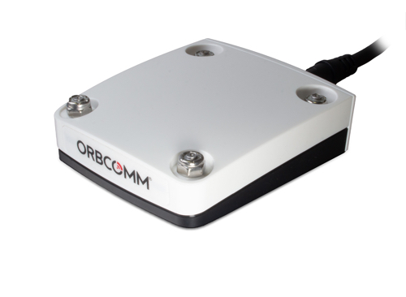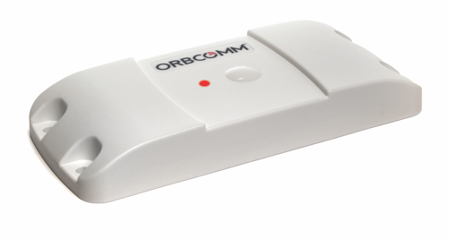
Monitor load status and identify the right trailer made easy -– with the CS 500 camera-based load sensor (left) and the IS 400 tractor ID system (centre, right). (Photos/graphics: ORBCOMM)

ORB_ST-2100.jpg
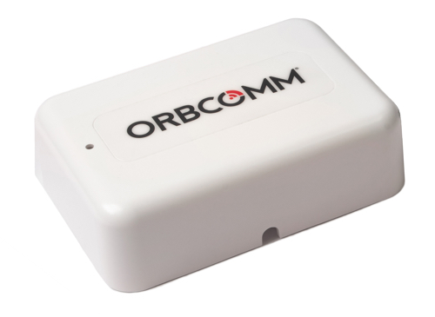

ST 2100: Provide cost-effective satellite connectivity to a variety of industrial assets in remote locations.
(Photos/Graphic: ORBCOMM)

Further informations:  ORBCOMM Inc., Lina Paerez  Tel.: +1 613 875 1485  paerez.lina@orbcomm.com  www.orbcomm.com | Press and Public Relations:  Press’n’Relations GmbH, Uwe Taeger  Magirusstraße 33, 89077 Ulm, Germany  phone.: +49 731 96 287-31  ut@press-n-relations.de  www.press-n-relations.de

About ORBCOMM
ORBCOMM is a global leader and innovator in the industrial Internet of Things, providing solutions that connect businesses to their assets to deliver increased visibility and operational efficiency. The company offers a broad set of asset monitoring and control solutions, including seamless satellite and cellular connectivity, unique hardware and powerful applications, all backed by end-to-end customer support, from installation to deployment to customer care. ORBCOMM has a diverse customer base including premier OEMs, solutions customers and channel partners spanning transportation, supply chain, warehousing and inventory, heavy equipment, maritime, natural resources, and government. For more information, visit www.orbcomm.com.

