Press INFORMATION
Botevgrad (BG), 6th October 2016

EU-Retest, Stability tests, EU-Market release:
GE with value-added-services for the pharmaceutical production

FMD compliant production and additional services – economical at EU-location Bulgaria

Since spring 2016 GE Pharmaceuticals facilitates the serialization of pharmaceutical packs in conjunction with an authentic closure. Thus the Austrian-Bulgarian packaging specialist in Europe became one of the first companies that already today can produce according to the EU anti-counterfeiting directive FMD (FMD stands for "Falsified Medicines Directive"). GE Pharmaceuticals is specialized in particular in the production of small batches: Last year the proportion of batches with less than 5.000 packs was 54% of the total production. In addition to the future security FMD-compliant manufacturing GE offers optional services around the EU import of medicines. The portfolio ranges from the EU-retest for finished medicinal products over the import and release of bulk for packaging to EU market release of drugs by Qualified Persons (QPs). With extensive laboratory capacity and newly built in 2015 second production plant, the testing and packaging are performed economically in the Bulgarian EU location in Botevgrad near Sofia. GE Pharmaceuticals addresses with its offer in particular pharmaceutical companies without own production and/or a high proportion of imported medicines from non-EU countries. "Our customers can obtain all services from a single source," says GE’s General Manager Dr. Günter Datz and continues: "On demand we take over the customs formalities for the import, the EU-retest, take care of the quality control of bulk, package FMD-compliant and complete the manufacturing process optionally also with the EU market release of the drug. In our analytical and microbiological laboratories we carry out with state of the art equipment all common analyses and offer to our clients stability tests too."

At the Botevgrad site GE Pharmaceuticals has been providing extensive services related to packaging of tablets and hard gelatin capsules since 2006. As one of Europe's first pharmaceutical companies, GE has been able to serialize drug packaging with 2D matrix code in conjunction with Tamper Evidence since April 2016. These two safety features will be compulsory for all pharmaceutical manufacturers as of 9 February 2019 by dint of the EU Falsified Medicines Directive 2011/62/EU (briefly FMD). For the German customer Wörwag Pharma, GE already produced FMD compliant in April 2016 as part of a pilot project.

In addition to production, GE Pharmaceuticals operates modern chemical and microbiological laboratories in Botevgrad, has its own "Regulatory Affairs" department and offers its value-added services based on this infrastructure, such as obtaining import and export permits, customs clearance, EU retests, stability studies and market releases. GE's chemical laboratory includes extensive equipment for the analysis of primary packaging, bulk and pharmaceutical finished products. The microbiological laboratory tests in particular the microbiological quality of non-sterile medical products, primary packaging and food supplements. In addition, water quality, GMP-compliant clean rooms and equipment are regularly checked. Three climatic chambers with different temperature and humidity zones are available for long-term stability tests. Stability studies for around 120 different medicines from a total of 15 GE customers are currently ongoing.

For the first time, the production facility was certified by the Austrian testing institute AGES in 2006. Over the past years numerous audits and re-audits have been carried out by customers as well as by the Bulgarian health authority BDA (Bulgarian Drug Agency). GE Pharmaceuticals is specialized in the production of small batches: last year, the share of batches with less than 5 000 packs was 54% of the total production, including batches of less than 1 000 packs with a share of 25%.

Images (Source: Bruno Lukas, Press’n’Relations GmbH):
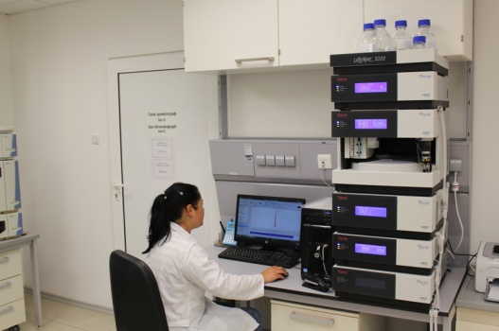
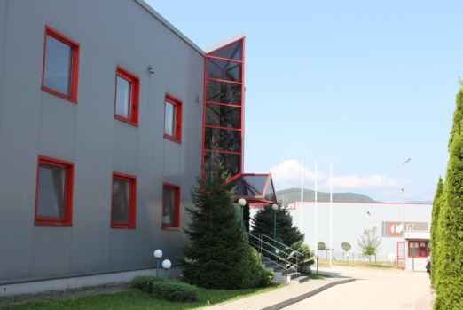

Plant 1 with the laboratories View at GE’s chemical laboratory
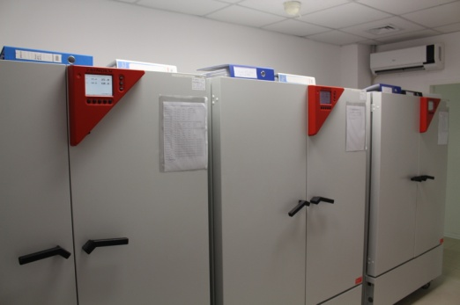
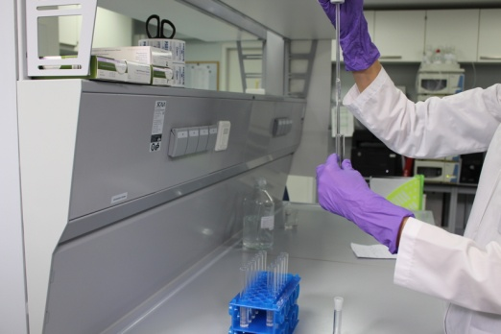

Chemical Analysis Climatic chambers for stability tests

Further information: Press relations:

GE Pharmaceuticals Ltd.  Dr. Günter Datz, General Manager  Angel Angelov, General Manager  Industrial Zone, Chekanitza South Area - BG-2140 Botevgrad  Telefon: +359 723 66 794  Telefax: +359 723 66 793  office@ge-ph.com  www.ge-ph.com | Press’n’Relations GmbH, Berlin Branch  Bruno Lukas, Branch Manager  Boyenstraße 41 – D-10115 Berlin-Mitte  Telefon: +49 30 - 577 00-325  Telefax: +49 30 - 577 00-324  blu@press-n-relations.de  www.press-n-relations.de

GE Pharmaceuticals Ltd.
With currently 190 employees GE Pharmaceuticals Ltd in Botevgrad (Bulgaria) produces annually about 60 million blisters and 20 million packages of drugs. With the commissioning of the second manufacturing site in September 2015 the number of production lines increased to six - with the option to launch in future another twelve lines additionally. The Austrian-Bulgarian company was founded in 2005 as a joint venture with 31 employees. It is owned respectively to 50 percent by Ecopharm Ltd. and by Genericon Pharma Ltd, one of Austria's largest manufacturers of generics.

