Press RELEASE
Botevgrad (BG), 12 October 2015

Packing, serialization, EU-retest, laboratory-services:
GE Pharmaceuticals Ltd. with full service for the European pharmaceuticals market

Packing company provides protection for clients in production, quality security and distribution of pharmaceutical products for the EU Market.

Under the slogan “European quality at reasonable prices” GE Pharmaceuticals Ltd. with seat and management address in Botevgrad, near Sofia, Bulgaria has offered their packing services to European pharmaceutical producers since 2006. Services include both the primary and secondary packaging of pharmaceuticals with accompanying laboratory analyses. In addition, the Austrian-Bulgarian packaging specialist can take over the introduction of pharmaceuticals in the EU market, including tax and customs-processing, and EU retesting and marketing of goods. With the expansion of production at a second plant in September 2015, GE Pharmaceuticals is able to offer the serialization of secondary packaging on the basis of the 2D matrix codes from 2016 onwards. This will be done in combination with specially developed cartons, utilizing hot and cold-adhesive tamper evidence technology.

When planning the second production facility, special emphasis was placed on the following:

- Material flow in one direction. Inflow and outflow of goods take place at opposite ends of the factory.
- Monitoring of clean room area, the area for secondary packaging and the entire space by calibrated sensors and the control of temperature and relative humidity by a Siemens-based Building Management System.

The partners of GE Pharmaceuticals can benefit from other projects and innovations from 2016 such as:

- Interactive integration of proprietary software for production planning, which will allow customers to validate their production orders.

- EWC, Electronic Batch Records, which will sustainably improve the security of data transmission between ordering, controlling production lines, manufacturing processes and documentation history.

As a full service provider, GE Pharmaceuticals is a central link between the raw material supplier from non-EU regions and target markets in Europe. As a joint subsidiary of the Bulgarian Ecopharm and the Austrian generics market leader Genericon, GE now serves 40 markets, mainly in Europe, including his own mother company in Austria. A specialist in small series with lots of well below 10,000 packs, GE takes advantage of low Bulgarian labour costs in order to allow for a high proportion of manual production in economical and highly efficient production. "One of our goals is to be the service provider to meet the requirements for serialization and tamper evidence implementation as soon as possible, even in manual re-packaging of pharmaceuticals", emphasizes Günter Datz, CEO of GE.

In addition to its cost-efficient manual production, GE offers state-of-the-art production technologies on modern blister-pack and cartooning machines for their core business, the packing of medicines. GMP certified laboratories, analytical laboratories and a microbiology laboratory are available for quality assurance. The production range includes packing of all tablet shapes and hard-gelatin capsules.

In the production of blister-packs and cross-perforation unit dose blister printing and Peal-Off closures as well as standard closures are possible. With serialization in conjunction with the innovative tamper evidence method of German specialist Baumer HHS GmbH, GE enables the production of counterfeit-proof drug packaging from 2016 on. The folding is supplied by the German manufacturer Kroha GmbH, responsible for the innovative packaging design.
The serialization itself, when each package is given a unique serial number, requires an IT server infrastructure with appropriate encryption and the highest security level. GE implemented this project with the leading Bulgarian provider of Secure-Server infrastructure: Neterra Ltd. from Sofia. The implementation of technology for the serialization of the packaging lines is carried out jointly with the Bulgarian IT specialists Soft Group Ltd.

The GMP-qualified stock GE produced at the new Plant 2's six production lines in 2016 was initially on two levels. The relative humidity of the medicines within the blister-packs can be controlled on two of these lines, with values below 40% relative humidity achieved. On the second level of Plant 2, up to eight production lines can be installed if needed. The existing Plant 1 will be used from next year onwards as a production area for repacking projects, for the production of small batches of less than 1,000 packages, and for the filling of bottles. GE Pharmaceuticals can operate in its final stage in both plants up to a total of 18 production lines.

Picture material:

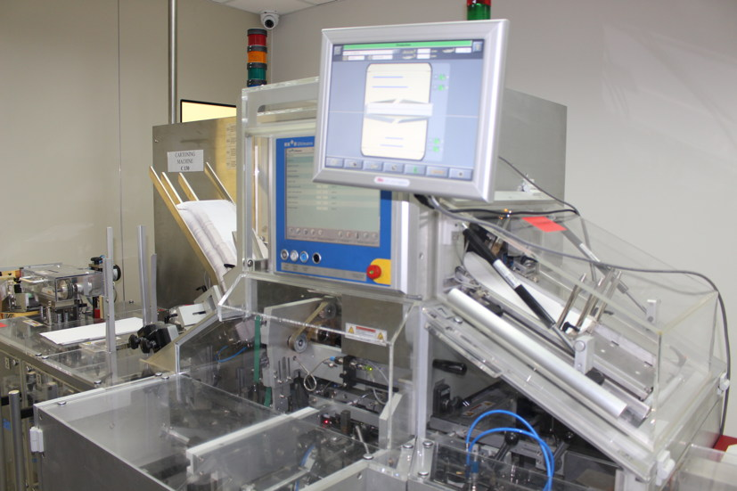
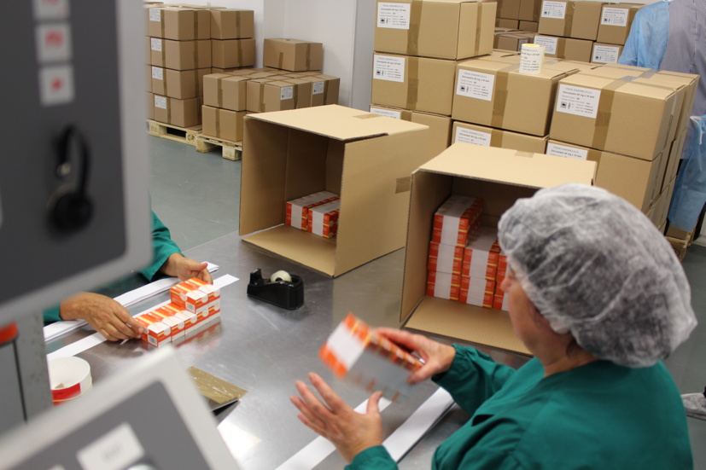

Examination of finished goods and packaging in cartons Cartooning machine in plant 2

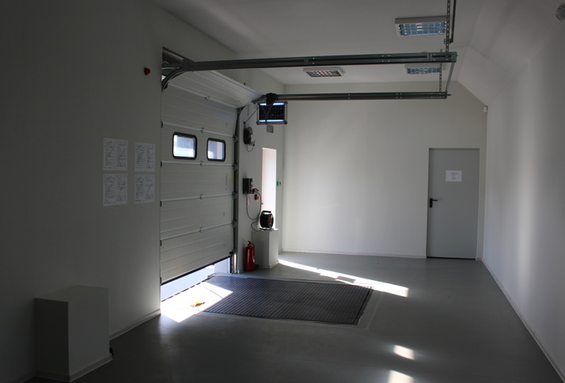
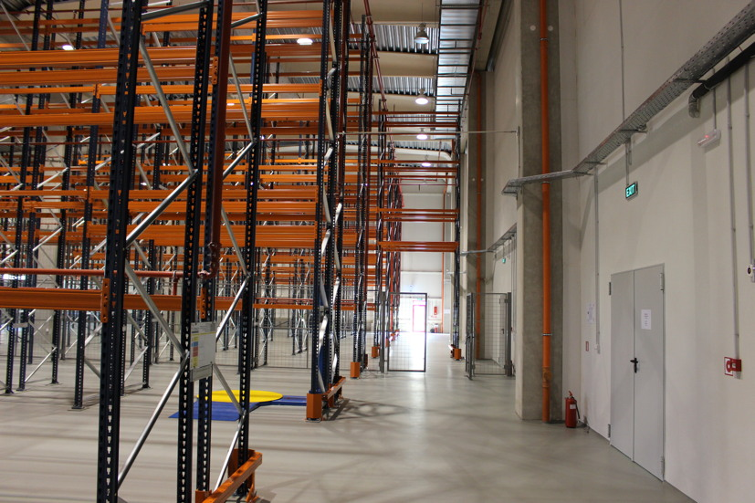

GMP-qualified stock for raw materials and finished goods Unloading zone in plant 2

Pictures can be downloaded here: www.press-n-relations.de - in the attachment of the press release published on the website (Category “News”).

Additional Information: Press Relations:

GE Pharmaceuticals Ltd.  Dr. Günter Datz, Manager  Angel Angelov, Manager  Industrial Zone, Chekanitza South Area - BG-2140 Botevgrad  Phone: +359 723 66 794  Fax: +359 723 66 793  office@ge-ph.com  www.ge-ph.com | Press’n’Relations GmbH, Berlin Office  Bruno Lukas, Branch Manager  Boyenstraße 41 – D-10115 Berlin-Mitte  Phone: +49 30 - 577 00-325  Fax: +49 30 - 577 00-324  blu@press-n-relations.de  www.press-n-relations.de

GE Pharmaceuticals Ltd.
With currently 150 employees, the four production lines of GE Pharmaceuticals Ltd. turn out 60 million blister-packs and 20 million pharmaceutical products. With the commissioning of a second production plant in September 2015, the number of production lines was increased to six, with the possibility of up to twelve additional lines in the future. The Austrian-Bulgarian enterprise was founded in 2005 as joint venture with 31 employees – with a share of 50 percent each of Ecopharm Ltd. and Genericon Pharma Gesellschaft mbH, one of the largest Austrian producers of generic pharmaceutical products.

