PRESS RELEASE
Botevgrad (BG), 2 October 2015

GE Pharmaceuticals Ltd. with a new plant and new services:
Serialization and tamper evidence combined

The united subsidiary of Genericon and Ecopharm now allows the production of pharmaceutical products in accordance with the 2019 EU-Counterfeit protection guidelines.

Exactly on the tenth anniversary of the founding, the Bulgaria-based company GE Pharmaceuticals Ltd. opened their GMP-qualified production line with storehouse on 15 September 2015 in Botevgrad. As one of Europe's first enterprises in the pharmaceutical field, the packing company allows to serialize the packing of medicines with 2D-matrix-code with tamper evidence. These two security features will be mandatory for all pharmaceutical producers according to EU-Guideline 2011/62/EU, which comes into effect in 2019. “After the completion of the validation process, we can already provide products for our clients in accordance with the new guidelines from 2016 onwards”, says Günter Datz, the manager of GE Pharmaceuticals. Apart from this technological project, GE's clients will also take advantage of the various efficient and economical production processes. These results arise from the state-of-the-art production technologies in connection with the highest EU security standards, as well as advantageous pay costs on the site of the EU-member Bulgaria. With currently 150 employees, the four production lines of this enterprise turn out 60 million blister-packs and 20 million pharmaceutical products. With the commissioning of the second production plant, the number of production lines was increased to six, with the possibility of up to twelve additional lines in the future. The Austrian-Bulgarian enterprise was founded in 2005 as joint venture with 31 employees – with a share of 50 percent each of Ecopharm Ltd. and Genericon Pharma Gesellschaft mbH, one of the largest Austrian producers of generic pharmaceutical products.

Since 2006, GE Pharmaceuticals has offered a great number of services in connection with the packing of tablets and hard-gelatine capsules. The portfolio ranges from the customs service on the implementation of EU retests to primary and secondary packaging and manual packaging. Of course, GE Pharmaceuticals provides all the necessary laboratory tests, stability tests and the release of packaged products by qualified personnel. The GMP-qualified manufacturing facility has been certified first by the Austrian Test Institute AGES. In recent years, more than 65 audits and re-audits have been carried out by customers as well as the Bulgarian Health Authorities BDA (the Bulgarian Drug Agency). In addition to producing, GE Pharmaceuticals operates chemical and microbiological laboratories in Botevgrad, which provide appropriate laboratory services to external partners. GE Pharmaceuticals has specialized in particular in the production of small batches: last year the proportion of batches was less than 5,000 packs (54% of total production), including batches with less than 1,000 packages (25%).

Inauguration of the new production facility - lectures, guided tours and live-demo
With the opening ceremony on 16 September 2015, the new plant 2 was opened. The opening took place in presence of the owners, in the presence of representatives of the Bulgarian Ministry of Health, the Bulgarian Drug Agency, the relevant authorities in the company and representatives of the Orthodox Church participating. The co-owner Dr. Peter Velev and Mag. Philipp Schramel, economic delegate of the Austrian Chamber of Commerce in Sofia, ended the ceremony by cutting the opening ribbon together. In a ceremony with colleagues from GE Pharmaceuticals Ltd., the General Managers Dr. Günter Datz and Angel Angelov reminisced about their experiences during the first decade of existence of the company: 16 of the 31 employees of the "first hour" are still working with GE Pharmaceuticals.

On 17 and 18 September, guided tours were conducted in both production plants, at which 80 participants attended, mainly customers and service providers. In a lecture event with all participants, the CEO shared insights into the development of the company and its future direction. The planners and project participants at this event discussed the production technology at the new plant - including serialization using 2D-matrix-code and the implementation of tamper evidence, and what this means for hot and cold-adhesive technology. A demonstration of this packaging technology with sample goods in plant 2 was broadcast live in the lecture hall and was discussed by the speakers.

Photo material:
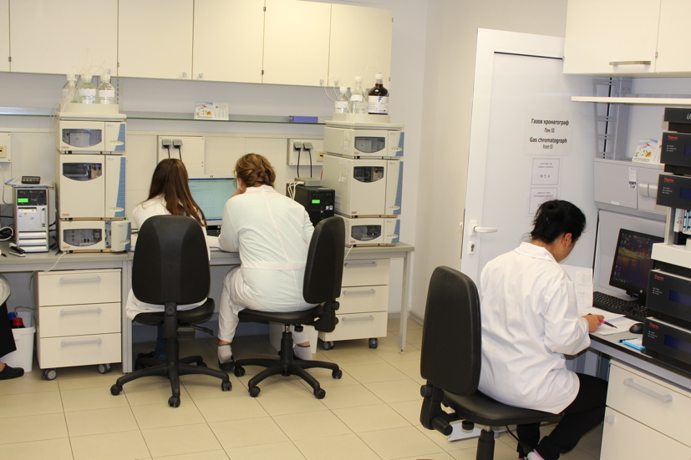
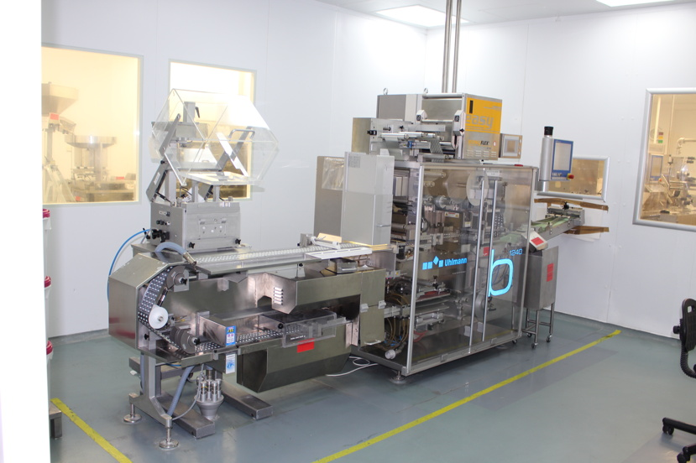
A blister-pack machine in Plant 1 of GE Analytical work of GE Pharmaceuticals

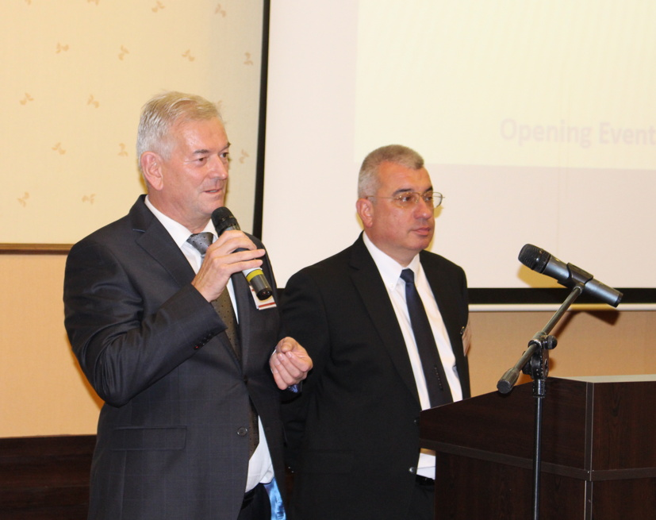
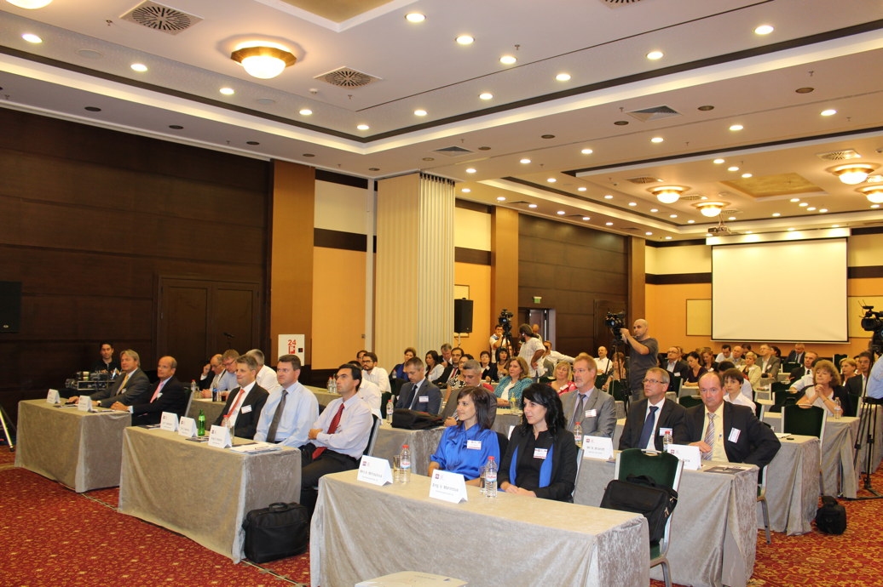

80 participants attended the lecture series of GE Dr. Günter Datz (left) and Angel Angelov (right)

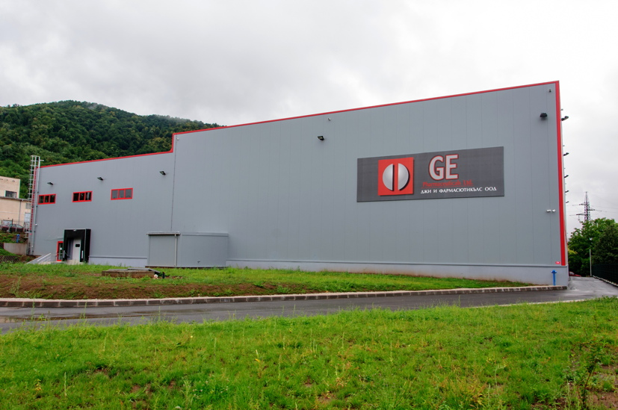
Pictures can be downloaded here: www.press-n-relations.de - in the attachment of the press release published on the website (Category “News”).
Plant 2 in Botevgrad, opened in September 2015

Additional Information: Press Relations:

GE Pharmaceuticals Ltd.  Dr. Günter Datz, Manager  Angel Angelov, Manager  Industrial Zone, Chekanitza South Area - BG-2140 Botevgrad  Phone: +359 723 66 794  Fax: +359 723 66 793  office@ge-ph.com  www.ge-ph.com | Press’n’Relations GmbH, Berlin Office  Bruno Lukas, Branch Manager  Boyenstraße 41 – D-10115 Berlin-Mitte  Phone: +49 30 - 577 00-325  Fax: +49 30 - 577 00-324  blu@press-n-relations.de  www.press-n-relations.de

GE Pharmaceuticals Ltd.
With currently 150 employees, the four production lines of GE Pharmaceuticals Ltd. turn out 60 million blister-packs and 20 million pharmaceutical products. With the commissioning of a second production plant in September 2015, the number of production lines was increased to six, with the possibility of up to twelve additional lines in the future. The Austrian-Bulgarian enterprise was founded in 2005 as joint venture with 31 employees – with a share of 50 percent each of Ecopharm Ltd. and Genericon Pharma Gesellschaft mbH, one of the largest Austrian producers of generic pharmaceutical products.

