
Press release
66 kV cables for the offshore wind industry
Nexans at the Hanover Trade Fair 2015, 13 to 17 April, hall 13, booth C45
Type tests for 630 mm² copper cables passed
Hanover, 13 April 2015 – With the development of 66 kV cables for the array cabling within offshore wind farms, Nexans has once more confirmed its technological leadership in this area. The new 630 mm² copper cables passed all relevant type tests, with preparations now ongoing for the final long-term test.
As a result of the trend towards increasingly powerful wind turbines, it is necessary to modify the array cabling. This is because if 36 kV offshore cables were used instead of 66 kV cables, despite the fact that the wind turbines are larger (with outputs exceeding 6 MW), more transformer stations would be needed. This would result in greater system losses and costs for the wind farms. However, 66 kV cables allow the familiar offshore layout to be maintained, with strings of four to five (or more) wind turbines standing in a row. There is no need to build additional platforms, which benefits the economic efficiency of an offshore wind farm.
“Nexans recognised the trend towards increasingly powerful turbines at an early stage and therefore began developing a 66 kV system. We have now defined our next objective: to develop a 66 kV subsea cable with a solid aluminium conductor,” says Matthias Kirchner, Director MV Submarine Cables.
(approx. 1,300 characters)

Picture: 66 kV.tif
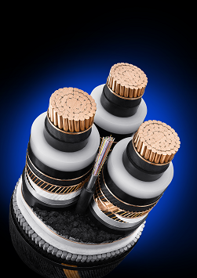
66 kV cables for the array cabling within the offshore wind industry

Nexans Germany
Nexans Germany is one of the leading cable manufacturers in Europe. The company is offering an extensive range of high performance cables, systems, and components for the telecommunications and energy sectors, rounded off by superconducting materials and components, Cryoflex transfer systems and special machinery for the cable industry. Producing at manufacturing plants with approx. 10,215 employees in Germany and abroad, the sales in 2014 amounts to approx. 933 Mio Euro. The full integration into the Nexans Group Nexans Germany also benefits from excellent opportunities to use the available synergies in all corporate fields, which not only applies to worldwide projects but also to research and development, the exchange of Know how, and to other areas. More information on www.nexans.de

Press Contact

Nexans Deutschland GmbH
Jutta van Buehl
Kabelkamp 20
30179 Hanover (Germany)
Phone: +49 (0)511 676-2629
Fax: +49 (0)511 676-2480
Mail: Jutta.van_Buehl@nexans.com
Website: www.nexans.de
Press’n’Relations II GmbH
Ralf Dunker
Graefstrasse 66
81241 Munich
Phone: +49 (0)89 5404722-11
Fax: +49 (0)89 5404722-29
Mail: du@press-n-relations.de
Website: www.press-n-relations.de

